EI1EL2 – Operational Amplifiers (Op-Amps) Part 2 - Practical

Equipment
Breadboard and Wire Leads | Power Supply
1 k, 3 k, 10 k, 100 k Resistors | Oscilloscope
TL071 Op-Amp IC | Signal Generator

Learning Outcomes

On Completing this laboratory, you should be able to:
- Connect-up and analyse experimentally some op-amp amplifier0020circuits,
- Compare simulation results with experimental results,
- Take good results with the oscilloscope.

Introduction
In the previous experiment, you used Proteus to simulate the open-loop characteristics of a TL071 op-amp, then the closed-loop characteristics of an inverting amplifier with gains of -10 and -100.

In this experiment you will repeat the closed-loop characterisation using real hardware. This will make use of the breadboarding skills and understanding of the power supplies you learned in EI1EL1 and the knowledge of the function generator and oscilloscope from week 1 of this module.
Later in the experiment you will also verify that the non-inverting amplifier configuration obeys the gain equation.

Part 0 – Setting Up the Equipment
Don’t be shy about asking for help if you get stuck, but at the same time, you need to be able to use the equipment confidently and competently and the only way to do that is to use it. Make copious notes in your lab book about settings, wiring, calculations, take photographs etc.

In the previous experiment you sent a set-up file to the oscilloscope to initialise it. This will be a reasonable starting point, so follow the instructions from that script.

Similarly, set the function generator as per last week’s experiment. This is a good way to verify that the equipment is working (or not, sometimes).

Adjust CH1’s scale on the oscilloscope until the trace is as big as possible without going beyond the top and / bottom of the screen.

The measurements you will take will be with an input of 250 mV_{peak-to-peak}, so we’ll set that now. At the moment, you should have 1 V_{peak-to-peak}. Slowly turn the amplitude knob on the function generator while watching the peak-to-peak reading for CH1 change. You’re aiming for 250 mV, and as the waveform reduces. While you’re doing this, keep adjusting CH1’s scale on the oscilloscope until the trace is as big as possible without going beyond the top and / bottom of the screen.

At this point you should have a 250 mV_{peak-to-peak}, 1 kHz sine wave displayed on the oscilloscope clearly.

Have a demonstrator check your settings are correct before continuing.

Connect leads to the Power Supply as shown in figure 2, using the colours shown (this is why there is two green wires in the drawer). The ±15 V leads will power the TL071 through pins 7 and 4 (figure 1).

Adjust both outputs to 15 V.

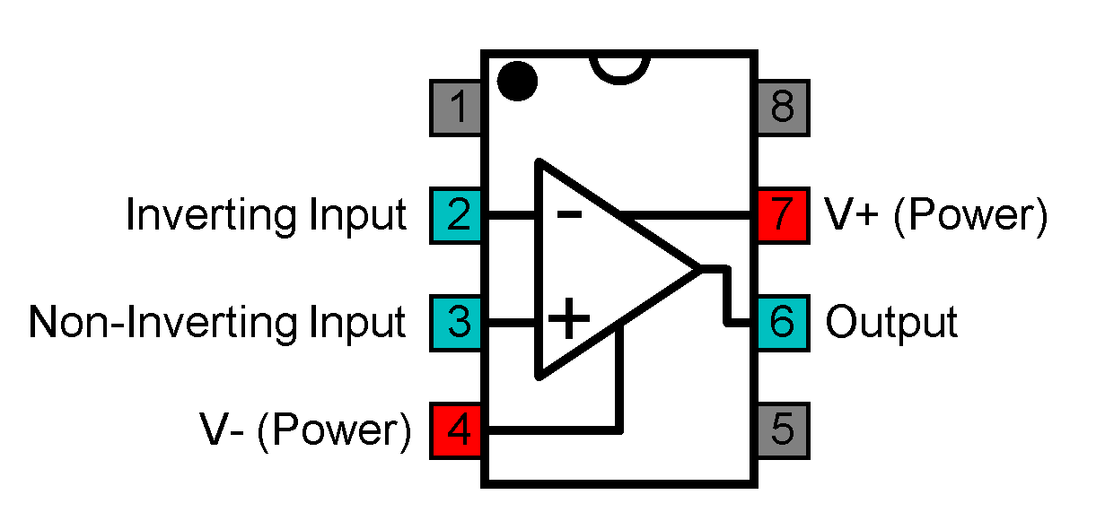  Figure 1 - TL071 Pinout | 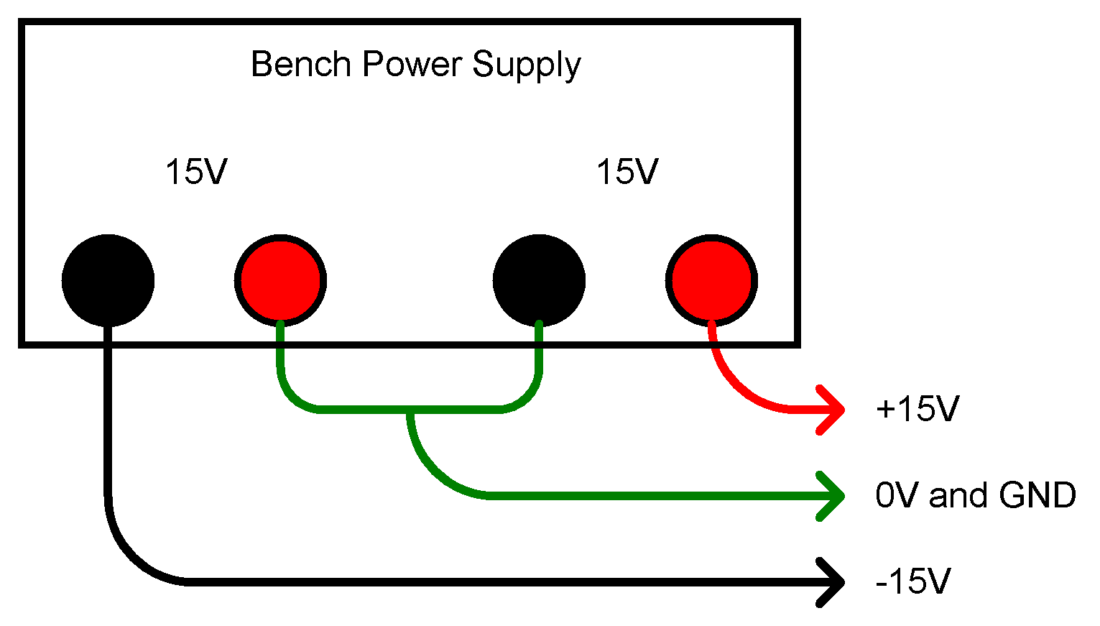  Figure 2 - Power Supply Connections

Part 1 – Inverting Amplifer (Gain of 10) 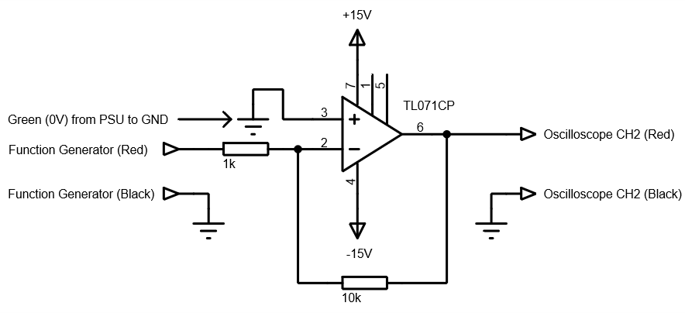
Figure 3 - Inverting Amplifier

- Build the circuit in figure 3 on a breadboard. The pin-out of the TL071 is given in figure 1, while figure 2 shows how to obtain +15V, -15V, and 0V from your power supply. Note that 0V on the power supply connects to the ground  on the circuit diagram and the function generator and oscilloscope. We know from experience that powering the op-amp in this way confuses a lot of students at first, so you must sketch the wiring in your lab book. You may also want to take a photo of your set-up.
- Switch the PSU’s output on. If either of the PSU’s red current limit lights show, ask for help.
- Turn Channel 2 of the oscilloscope on if there is no blue trace showing. CH2 should be vertically centred, and you will need to adjust CH2’s scale so it is as big as possible without going beyond the top and / bottom of the screen, just like CH1.
- Check the gain $\left(\frac{CH2}{CH1}\right)$. Is it as expected? Yes
- Take a screenshot and paste it below: 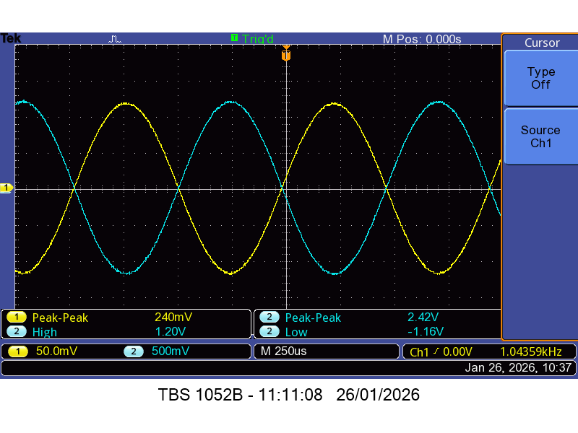
- Open the Excel file from the previous op-amp experiment and create a new worksheet.
- Edit the new worksheet to match figure 4. This shows the frequencies you will be testing the circuit at, as well as the readings you will take and the data to be generated and plotted. The shaded columns are calculated by Excel, rather than you doing it by hand. Gain is V_{out} / V_{in}, and Gain (dB) is 20 x Log₁₀(Gain).
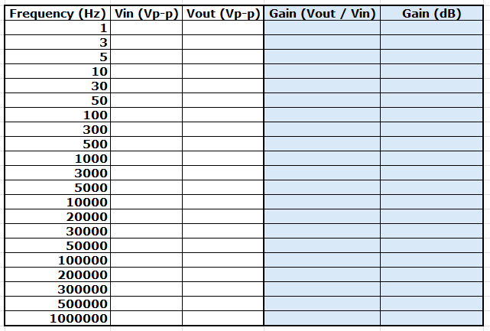
Figure 4 - Excel Layout
- On the function generator, press the 50 mHz button so the frequency is now 100 Hz, then adjust the oscilloscope’s Horizontal Scale until you can see 2 – 4 cycles and the trigger information reads 100 Hz
- Press the 50 mHz button again so the frequency is now 10 Hz, then adjust the oscilloscope’s Horizontal Scale until you can see 2 – 4 cycles and the trigger information reads 10 Hz. This is the lowest frequency the oscilloscope can trigger, so to measure down to 1 Hz, we will need to do something different.
- Press the 50 mHz button again so the frequency is now 1 Hz, then adjust the oscilloscope’s Horizontal Scale until you can see 2 – 4 cycles being drawn. The trigger information should now read <10 Hz and the oscilloscope is in scan mode. In scan mode the readings don’t work, however.
- To fix this, we can set the oscilloscope to take a screen’s worth of data and stop. It can then take readings.
- On the top-right of the oscilloscope’s front panel there is a button named Single. Pressing this will do what we need – try it. Above 10 Hz, you can return to triggered mode by pressing the Run / Stop button, which should be green when running normally.
- Measure the input and output voltages of the circuit at the frequencies in figure 4. For every frequency, ensure that you can see 2 – 4 cycles and that both waveforms are as big as possible without exceeding the top and bottom of the screen.
- In Excel plot an XY Scatter graph of Gain (dB) against Frequency (Hz), as shown in figure 5. The frequency axis should be changed to logarithmic.
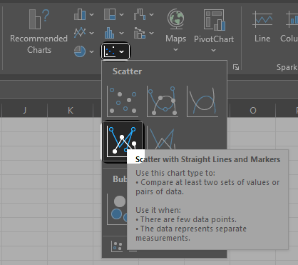
Figure 5 - Inserting an XY Scatter Graph

Part 2 – Inverting Amplifer (Gain of 100)
- Make a copy of Task 1’s table of data in the same worksheet,
- Delete the V_{in} and V_{out} data from the coped table. The formulae from task 1 will carry over,
- Swap the 10 k resistor for a 100 k one and repeat the measurements, including the screenshot at 1 kHz,
- Plot the data from this section on the same graph as part 1.

Part 3 – Gain-Bandwidth Product
- Calculate the gain-bandwidth product for parts 1 and 2 the same way you did for the simulation
- How do they compare to the simulated TL071?
Show your work to a demonstrator.

Part 4 – Non-inverting amplifier 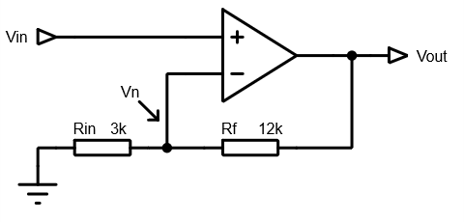
Figure 6 - Non-Inverting Amplifier
Figure 6 shows a non-inverting amplifier. As in the previous script, we’ll derive the gain equation using the same rules.

A voltage is applied to V_{in}. Applying rule (1), the voltage at V_{n} must also be V_{in}.
This means that the voltage developed across R_{in} is V_{in}.
Applying rule (2), as no current flows in or out of the op-amps inputs, R_{f} and R_{in} form a potential divider. Redrawing might help.
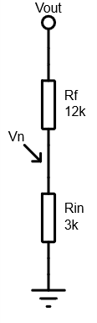
Using the potential-divider equation, we can say that:
$$V_{n}=V_{out}×\frac{R_{in}}{R_{in}+R_{f}}$$

Divide both sides by V_{out}:
$$\frac{V_{n}}{V_{out}}=\frac{V_{out}}{V_{out}}×\frac{R_{in}}{R_{in}+R_{f}}=1×\frac{R_{in}}{R_{in}+R_{f}}=\frac{R_{in}}{R_{in}+R_{f}}$$

Leaving:
$$\frac{V_{n}}{V_{out}}=\frac{R_{in}}{R_{in}+R_{f}}$$

Invert both sides:
$$\frac{V_{out}}{V_{n}}=\frac{R_{in}+R_{f}}{R_{in}}$$

Split the fraction:
$$\frac{V_{out}}{V_{n}}=\frac{R_{in}}{R_{in}}+\frac{R_{f}}{R_{in}}$$

Cancel R_{in} / R_{in} and substitute V_{in} for V_{n}:
$$\frac{V_{out}}{V_{in}}=1+\frac{R_{f}}{R_{in}}$$

This means the minimum gain of a non-inverting amplifier is 1 (unity).

Using the example in figure 6:
$$\frac{V_{out}}{V_{in}}=1+\frac{12000}{3000}=1+4=5$$

Calculate the gain of the circuit in figure 7:
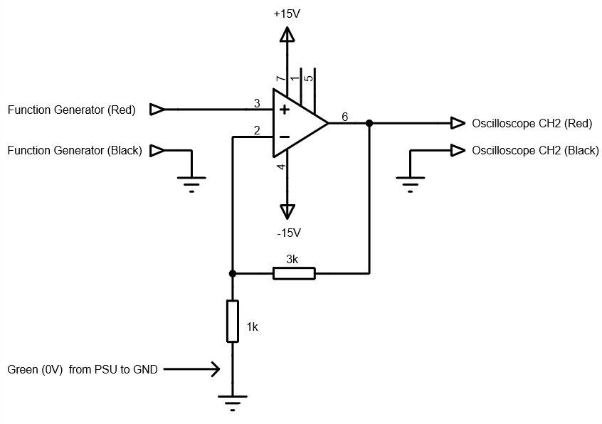
Figure 7 - Non-Inverting Amplifier
Build the circuit in figure 7 on breadboard and test it with a 1 kHz sinewave with a peak-to-peak voltage of 500 mV. As always, adjust the oscilloscope’s horizontal and vertical scales to give the best readings. Paste a screenshot below:
Calculate the gain from the measured peak-to-peak voltages:
Does it match the calculated value?
Replace the 3 kΩ resistor with 10 kΩ. Recalculate and measure the gain, and paste a screenshot here:

Show your work to a demonstrator.

1Hz
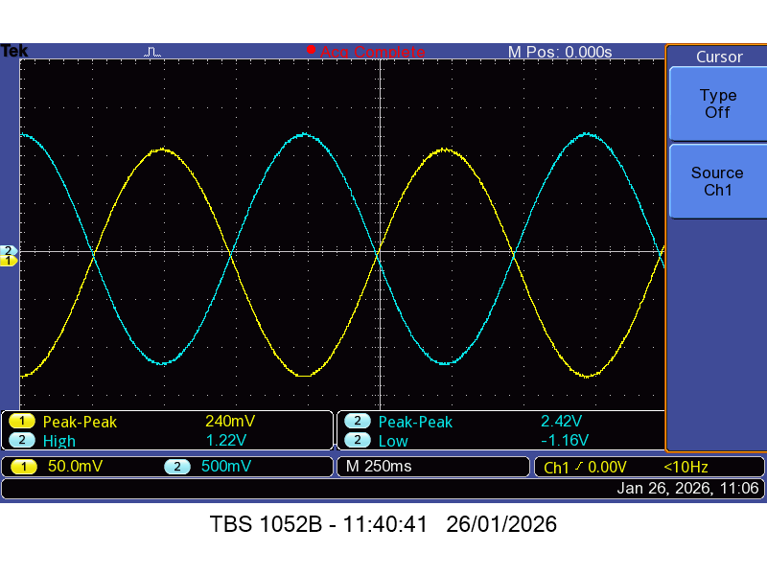
3Hz
5Hz

10Hz

